**Experiment No. 3.3**

**Student Name:** Gaurav Kumar **UID:** 22MCC20177

**Branch:** MCA**–**CCD **Section/Group:** MCD-1/A

**Semester:** III **Date of Performance:** 15th Oct 23

**Subject Name:** CONTAINERIZATION **Subject Code:** 22CAH-742

WITH DOCKER

1. **Aim/Overview of the practical:**
   1. Cleaning Up Old Containers and Docker Images.
2. **Code for practical: (a)**

To clean up old containers and Docker images, you can use the following commands:

* docker container prune: Removes all stopped containers.
* docker image prune: Removes all dangling images.
* docker system prune: Removes all unused images, containers, volumes, and networks.

1. First Cleaning up Old Container. Then First check containers that are available:

$docker ps -a.

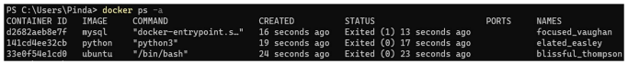

1. Then use docker container prune to clean up old container:

$docker container prune

* There will be WARNING that This will remove all stopped containers.
* Are you sure you want to continue? [y/N]
* Press Y for yes else N, then Enter.

1. **Cleaning up Old Images:**
2. First check images that are available:

$docker images

1. Then use docker image prune to clean up old dangling images:

$docker image prune

* There will be WARNING that This will remove all dangling images.
* Are you sure you want to continue? [y/N]
* Press Y for yes else N, then Enter.

1. Then use docker image prune to clean up all available images:

$docker image prune -a

* There will be WARNING that This will remove all images.
* Are you sure you want to continue? [y/N]
* Press Y for yes else N, then Enter.

